* + [Hardware Details](onenote:" \l "Valve%20Controller&section-id={609D1200-08E7-4586-A893-8A6B5C01DA95}&page-id={560AA3D0-4CC8-C74E-8C1F-07A643161CC7}&object-id={AA2B4464-EACD-6559-96B9-CEE832FB0EDE}&11&base-path=https://d.docs.live.net/befdfbd5220d5f12/Documents/RobinsonLab_SOP/Station%20SOPs.one)
  + [Operating the Valve Controller](onenote:#Valve%20Controller&section-id={609D1200-08E7-4586-A893-8A6B5C01DA95}&page-id={560AA3D0-4CC8-C74E-8C1F-07A643161CC7}&object-id={AA2B4464-EACD-6559-96B9-CEE832FB0EDE}&34&base-path=https://d.docs.live.net/befdfbd5220d5f12/Documents/RobinsonLab_SOP/Station%20SOPs.one)
  + Links to Supplies
  + Location: In E124 (confocal room)

**Hardware Details**

USB-based controller for 24 solenoid pneumatic valves

This is the open-source valve controller from Quake Lab

<https://sites.google.com/site/rafaelsmicrofluidicspage/valve-controllers/usb-based-controller>

(web address verified 2019)

This is what it looks like (image taken from above site)

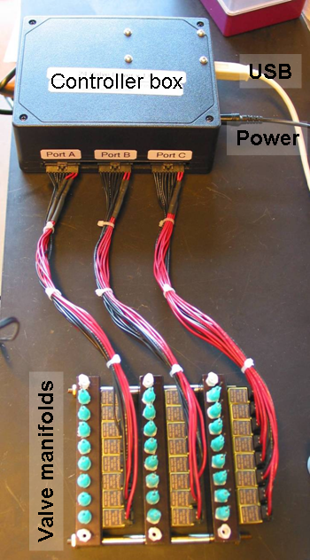

**Operating the Valve Controller**

* + Connect compressed air source (1/4" tubing) to the valve manifold.
  + Connect the Controller Box to Power
  + Connect the Controller Box via USB to a computer [Verified working on Win 10 + Matlab 2019, there is labview script online if desired]
  + Copy the contents of …\Valve Controller\ to a local directory on the computer [There have been issues connecting to the controller if the ftdxxx lib is not in local directory. Example errors from matlab include something about do not have permission to write to file]
  + Launch **ValveControllerGUI**.app

We have developed our own GUI (Initially designed for Hydra mechanical stimulation)

Valve Controller GUI 
Robinsonl-ab 
Instrument Control 
Mechanical Stimulation: Valve Controller 
Manual Control 
Valve # to open: 
Connect 
Controller Status 
Valve Controller 
Automatic Valve Control 
DI 
05 
30 
o 
Acclimation 
Period 
02 
06 
04 
07 
Valve # to open: 
1.5 
1 
0.5 
Run Protocol 
Stimulation Parameters: 
Experiment Duration (min) 
Acclimation period (min) 
Pressure (psi) 
Start 
Stimulus On Time (sec) 
Number of pulses 
Inter-Stimulus Interval (min) 
pulses 
Inter-Stimulus 
Interval 
Stimulus 
On Time 
0.5 
1 
5 
10 
Stimulation Protocol 
15 
Time (min) 
20 
x 
30 
25 
Save Params (.mat) 
Stop Protocol 

* + Click "**Connect Valve Controller**". **Controller Status** LED indicator should turn **green** and text should change to '**Connected**'. [If there is an error, terminate the GUI. Clear handles in matlab. Disconnect and reconnect the Controller box USB]
  + Manual Control: valves can be pressured by clicking the corresponding #. This should work in real-time.
  + Automatic Valve Control: valves can be orchestrated to turn on/off automatically so you can walk away from the experiment
    - Valve # to open: select the valve(s) you want to control
    - Stimulation Parameters: define parameters for the stimulation protocol
      * Experiment duration - The total duration of the experiment (in minutes)
      * Acclimation period - Start delay before beginning periodic stimulation. ( 1. allow animals to acclimate to the microfluidic environment/imaging lighting before beginning stimulation 2. control period used to compare behavior with and without stimulation)
      * Pressure - compressed air pressure reading from the pressure gauge connected to the valve manifold used to pressurize valves.
      * Stimulus On Time - time the valve stays open (sec)
      * Number of pulse - how many times valve opens and closes during single stimulation period
      * Inter-Stimulus Interval - time between two stimulation periods (min)
    - Plot shows stimulation protocol based on the params provided
    - Click '**Save Params(.mat)**' button to save the details of the stimulation protocol.
    - Click '**Run Protoco**l' button to begin the automatic valve controller sequence for stimulation protocol.
    - Click '**Connect Valve Controller**' button to disconnect from the valve controller when you're done. [Closing the app without disconnecting will cause connection errors next time you try to connect to the valve]